The “What if ? Birthday"

**A Story About Amelia**

As told to Grandpa Joe

[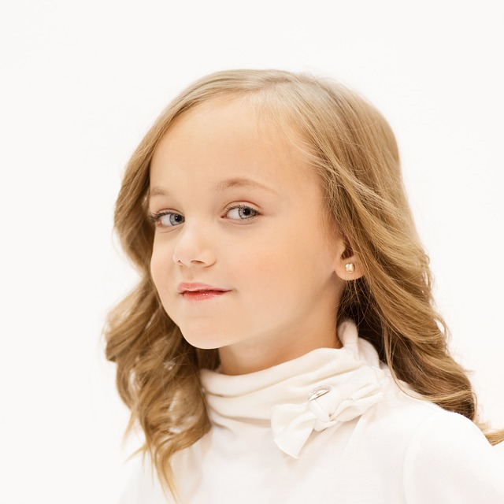](https://www.google.com/url?sa=i&rct=j&q=&esrc=s&source=images&cd=&cad=rja&uact=8&ved=0ahUKEwikj-P3wozMAhUCjz4KHdX3BpoQjRwIBw&url=https://pixabay.com/en/girl-young-blue-eyes-look-looking-545510/&psig=AFQjCNG7ynn76sexEoPYz9Od2pSPmWw2Xw&ust=1460668118494125)

Change name and insert picture of the child

**Yes way !!**

**You see on December 10**

**It’s her birthday.**

[](https://www.google.com/url?sa=i&rct=j&q=&esrc=s&source=images&cd=&cad=rja&uact=8&ved=0ahUKEwjB-diNzJHMAhWFs4MKHfwGDHcQjRwIBw&url=https://commons.wikimedia.org/wiki/File:Young_girl_in_Mauritania.jpg&psig=AFQjCNGiLIVBLIE8FWd_yn3M-8yINsd7GA&ust=1460842351314196)

Insert another picture of the child if available.

**It will be a ton of fun!**

**Hooray!!**

**Father said, “Let’s have a birthday party.**

**I’m sure it’s meant to be.”**

[](http://www.google.com/url?sa=i&rct=j&q=&esrc=s&source=images&cd=&cad=rja&uact=8&ved=0ahUKEwjQrLOj3azMAhWKMz4KHc6OCd0QjRwIBw&url=http://dexacor.com/studiojsite/service/father_son/&psig=AFQjCNHQ2vpV5Hn3_wPnaROuUGSLDjdgAQ&ust=1461774707557299)

Change text and insert picture of child’s dad. If there is no dad, this page can be deleted.

“But……What if ??”

Mother said.

[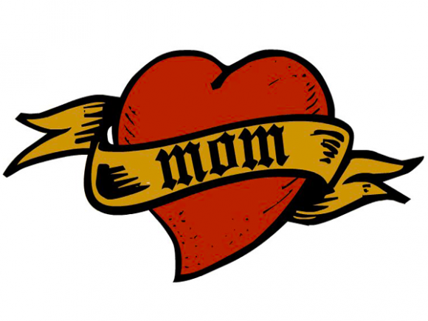](http://www.google.com/url?sa=i&rct=j&q=&esrc=s&source=images&cd=&cad=rja&uact=8&ved=0ahUKEwis_Yu5xYzMAhXJaD4KHY1BD5gQjRwIBw&url=http://www.hobodrifter.com/what-do-you-love-most-about-your-mother/&psig=AFQjCNElwR2572M16tuYfrrzLuesFnGjDQ&ust=1460668728758324)

Insert “mom” picture if available or use graphics provided.

[](http://www.google.com/url?sa=i&rct=j&q=&esrc=s&source=images&cd=&cad=rja&uact=8&ved=0ahUKEwjnvrnvxYzMAhUGFT4KHS6ZDJkQjRwIBw&url=http://www.inquisitr.com/2722187/mary-dye-virginity/&psig=AFQjCNElwR2572M16tuYfrrzLuesFnGjDQ&ust=1460668728758324)

**Sometimes mothers worry too much**

**About birthdays and such.**

**“But**

**What if ……..?**

**A magical wizard**

**Brings a giant blizzard.”**

[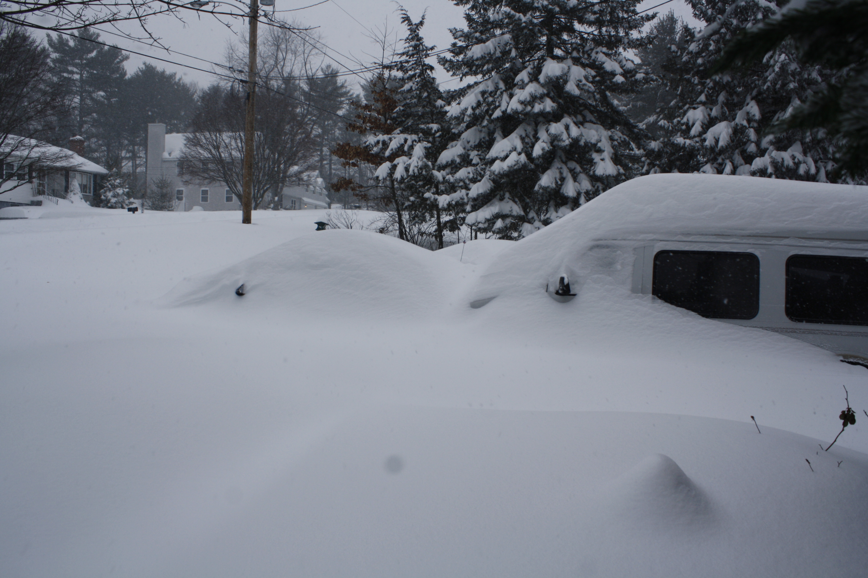](https://www.google.com/url?sa=i&rct=j&q=&esrc=s&source=images&cd=&cad=rja&uact=8&ved=0ahUKEwiu6ZmY-qnMAhUBvYMKHYQ0CNoQjRwIBw&url=https://en.wikipedia.org/wiki/February_2013_nor'easter&psig=AFQjCNHcwtD7Gj20Eqprc8uBWa3vUswFmQ&ust=1461679377838671)

**“What if ……..?**

There is a flood

With lots of water and mud?”

[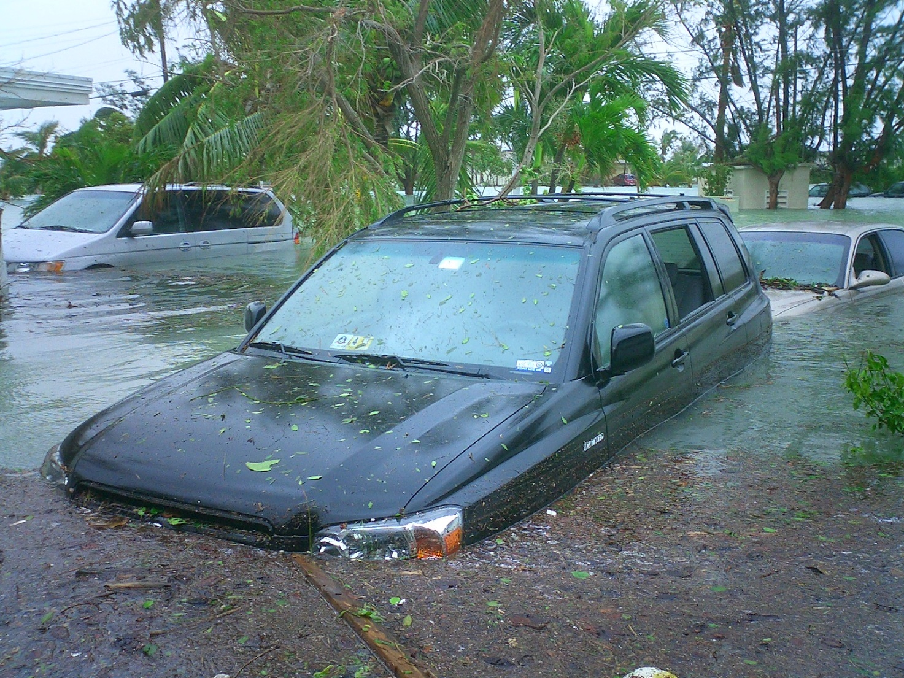](https://www.google.com/url?sa=i&rct=j&q=&esrc=s&source=images&cd=&cad=rja&uact=8&ved=0ahUKEwiEu9jfg6rMAhUBt4MKHbE6CEYQjRwIBw&url=https://en.wikipedia.org/wiki/Flood&psig=AFQjCNExWjSfEGzElGlQrrZ3VtAf-EYkPw&ust=1461681932653019)

**“What if ……..?**

**There is an earthquake**

**There would be no ice cream or cake!!”**

[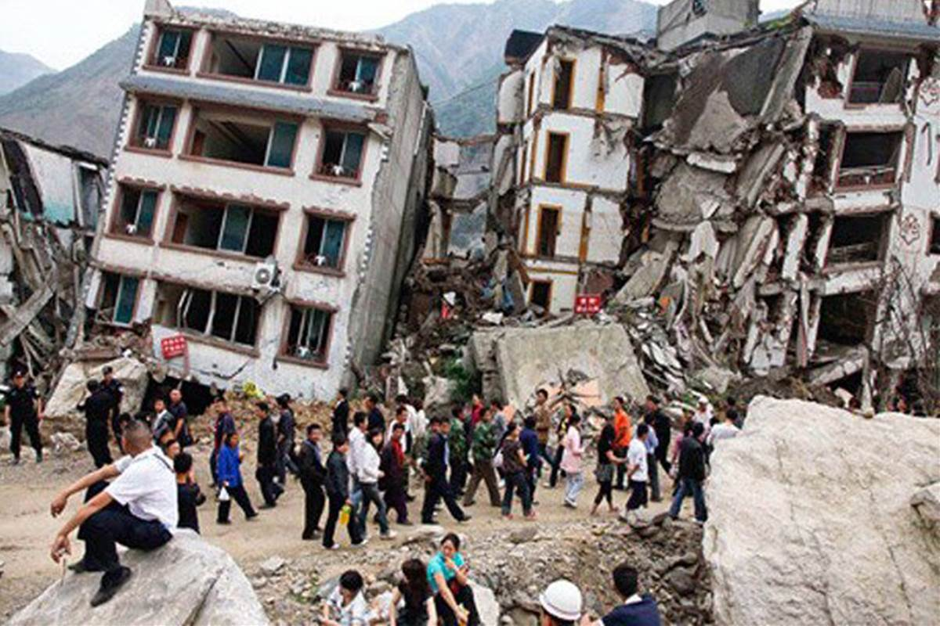](http://www.google.com/url?sa=i&rct=j&q=&esrc=s&source=images&cd=&cad=rja&uact=8&ved=0ahUKEwinyviqi6rMAhVHkoMKHYgXD84QjRwIBw&url=http://www.nbcnews.com/storyline/nepal-earthquake/nepal-earthquake-magnitude-7-9-tremor-hits-kathmandu-n348236&psig=AFQjCNGor4sPUG4cmqnUzHb94uesMqBz3Q&ust=1461683987198655)

Father said, “Don’t let the weather be your guide

We can always find space inside.

Rain or shine it will be fine.”

Insert picture if available

[](http://www.google.com/url?sa=i&rct=j&q=&esrc=s&source=images&cd=&cad=rja&uact=8&ved=0ahUKEwiU87ra4qzMAhVKSiYKHUJpDOAQjRwIBw&url=http://blogs.scientificamerican.com/psysociety/happy-fathers-day/&psig=AFQjCNH4TWtmhMvymey2ci5qkpbQmZFMCw&ust=1461776141007520)

“But……

**What if ……..?**

**“**

**Everyone gets the flu**

**What in the world can we do?”**

[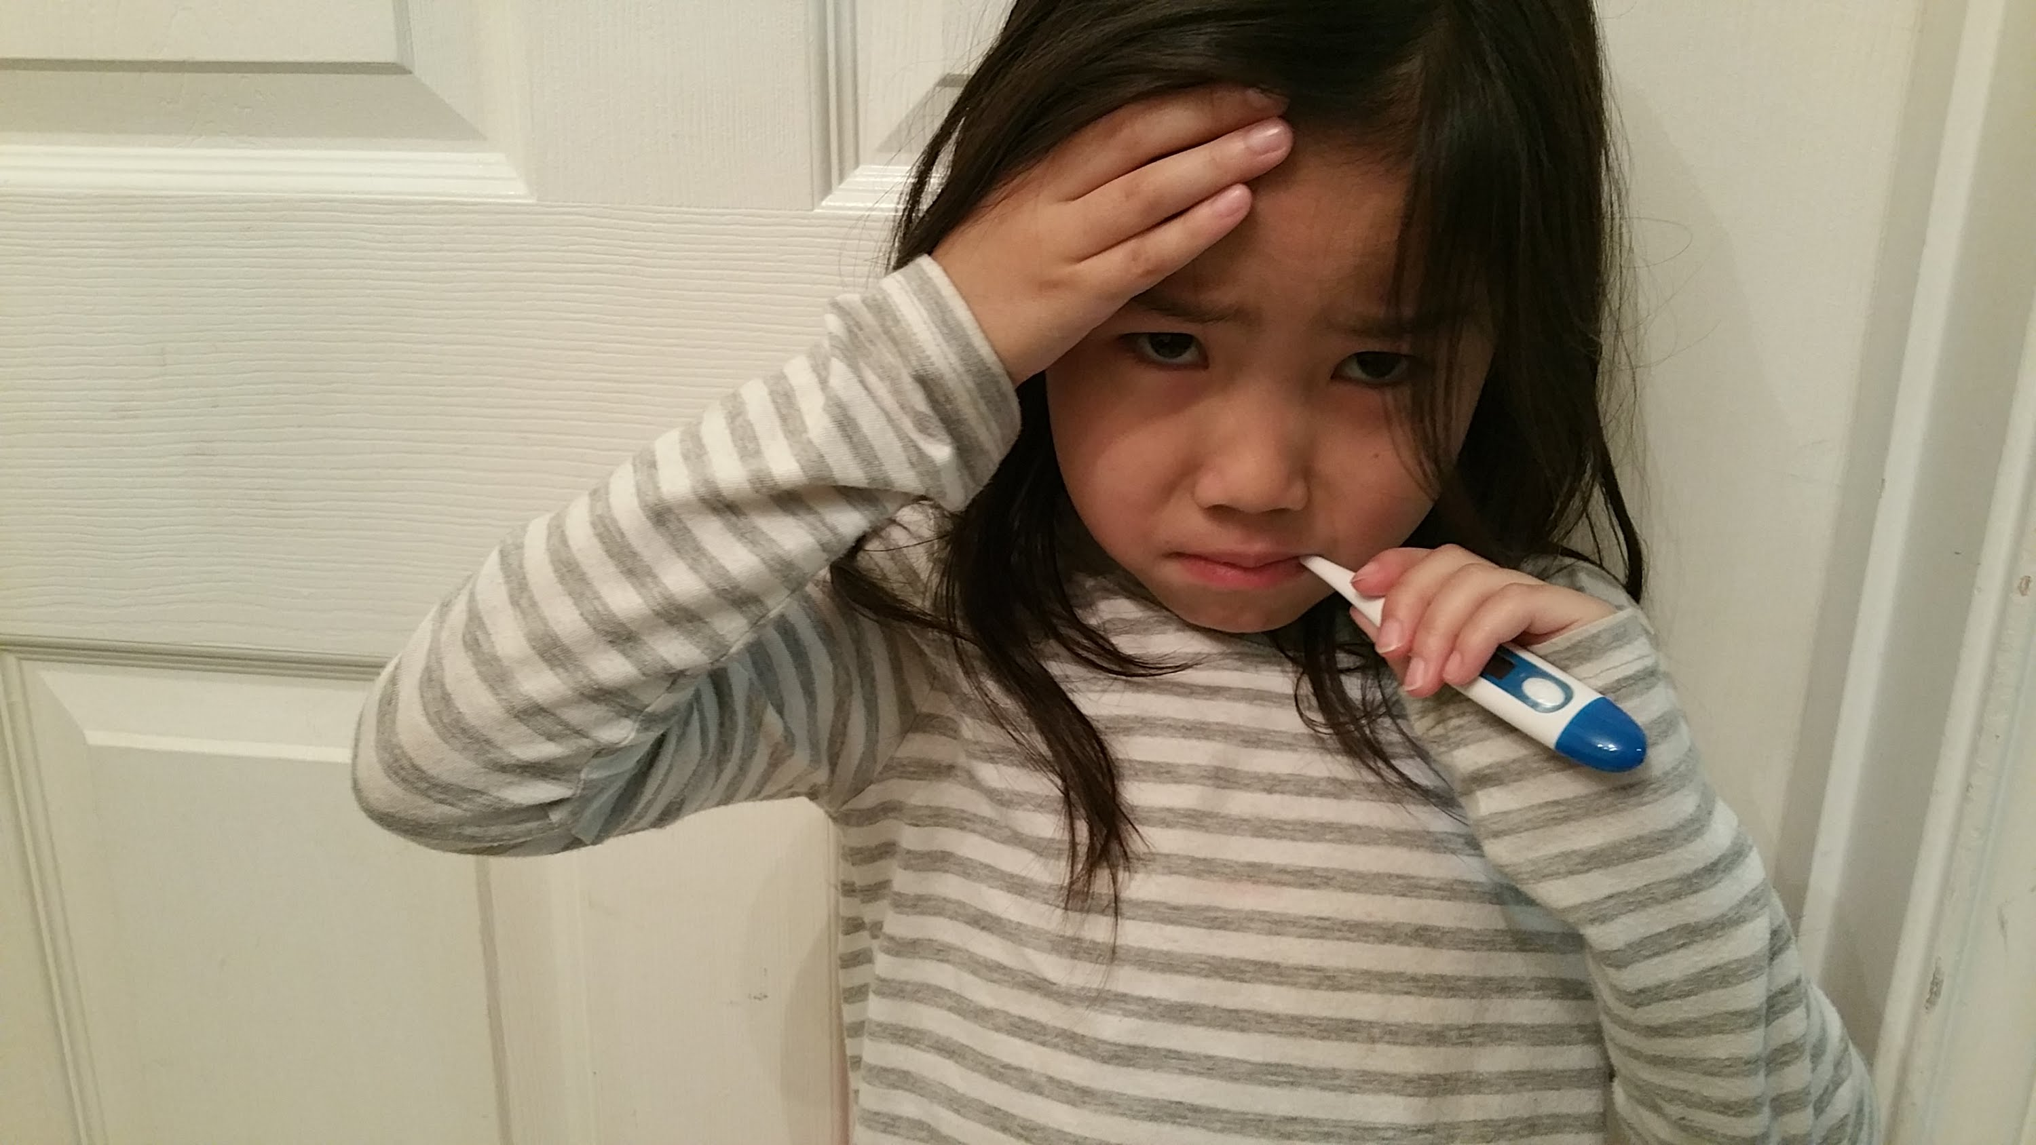](https://www.google.com/url?sa=i&rct=j&q=&esrc=s&source=images&cd=&cad=rja&uact=8&ved=0ahUKEwje_r2poarMAhUiyYMKHWgWAhYQjRwIBw&url=https://www.youtube.com/watch?v%3DZv8Qeon8IZ8&psig=AFQjCNH3ex-ctnqWgOduYrjkO0ul6ODEJg&ust=1461689865481664)

**Father said, “Then Instead**

**We will party in bed.”**

“But……

**What if ……..?**

**Our dog Fido ran away**

**and became a stray.”**[](http://www.google.com/url?sa=i&rct=j&q=&esrc=s&source=images&cd=&cad=rja&uact=8&ved=0ahUKEwim9tOk-LbMAhVpkIMKHWDdAb0QjRwIBw&url=http://animaliaz-life.com/dogs.html&psig=AFQjCNEuqZKFgO5au9SVgVJT6B8tSWiFtQ&ust=1462125553786605)

Any pet, any name

“But……

**What if ……..?**

**We can’t find the right gift**

**What if it is too heavy to lift?”**

[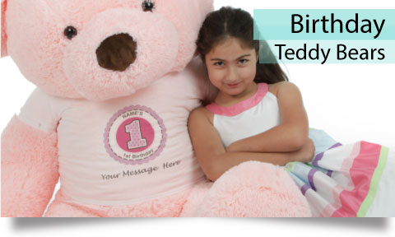](http://www.giantteddy.com/birthday-teddy-bear/)

**Exasperated**

**Father said, “Even if it is as heavy as a train we can move it with a crane.”**

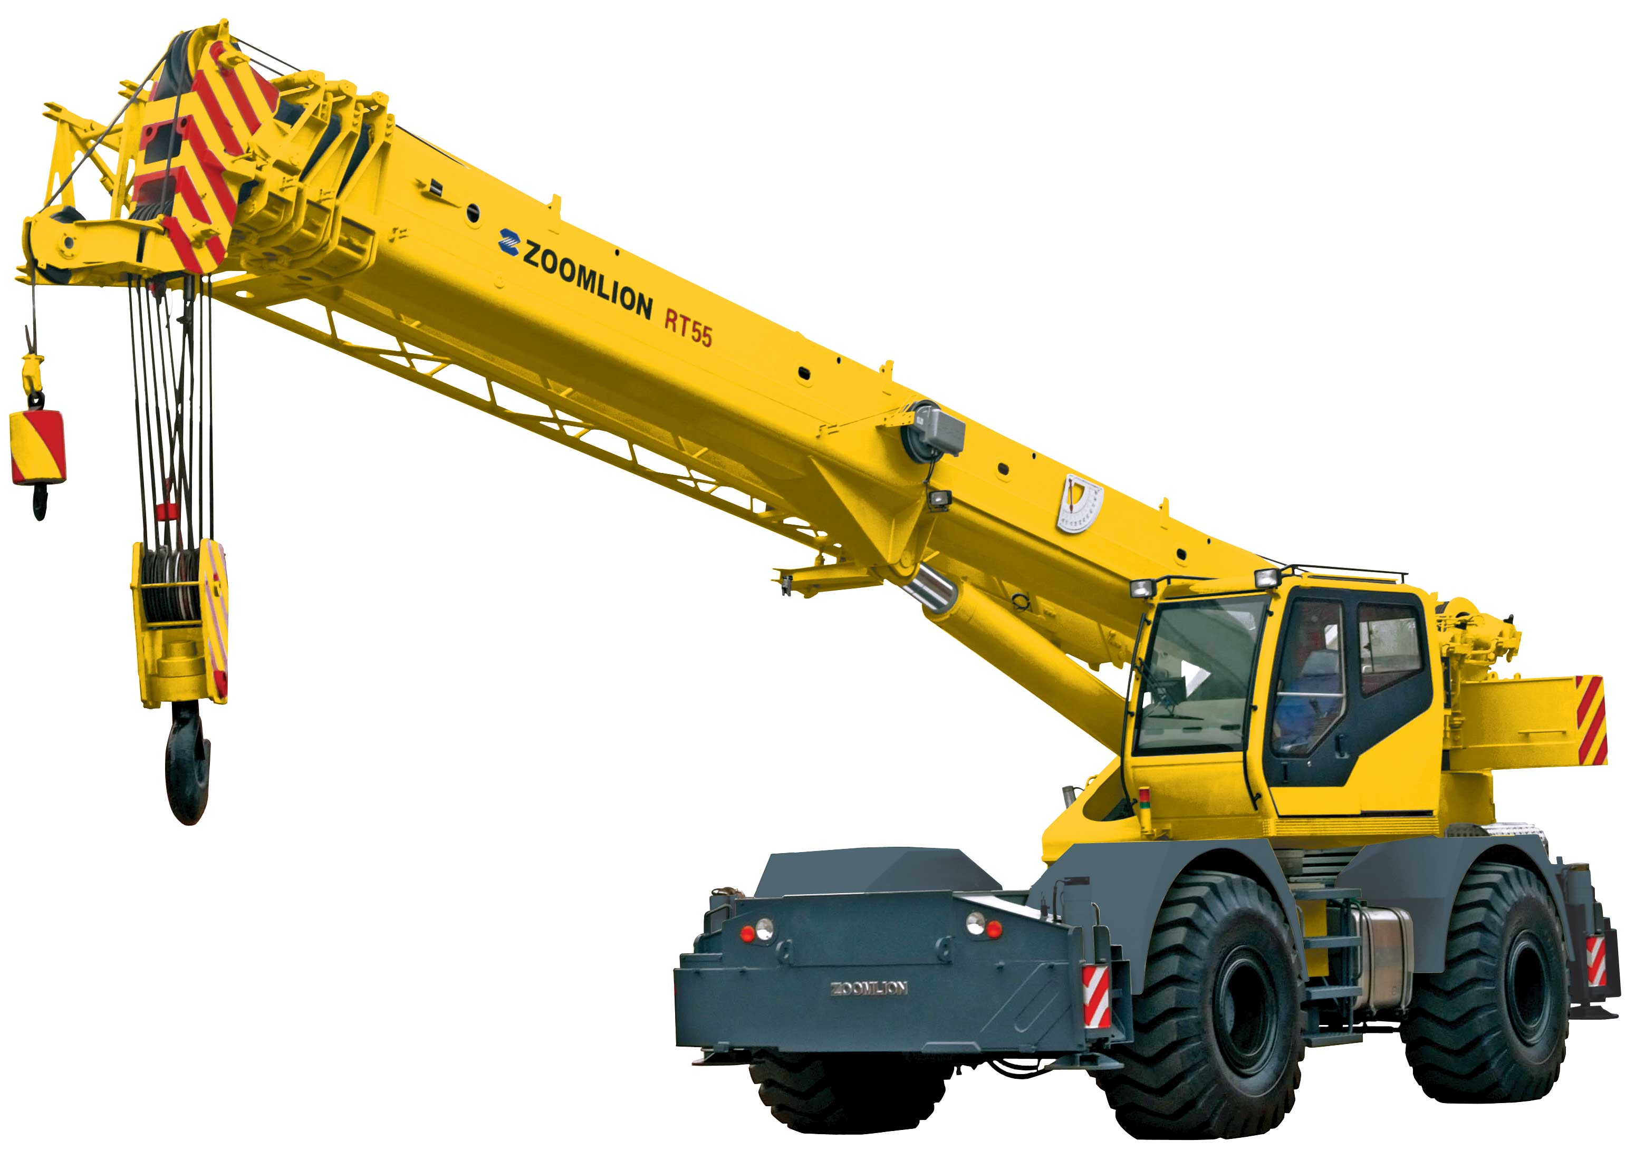

**Mother replied,**

**“Such a big rig. It will be too hard**

**To fit it in our backyard.”**

“But……

**What if ……..?**

**We happen to meet**

**A herd of buffalo in the street.”**

**A**

[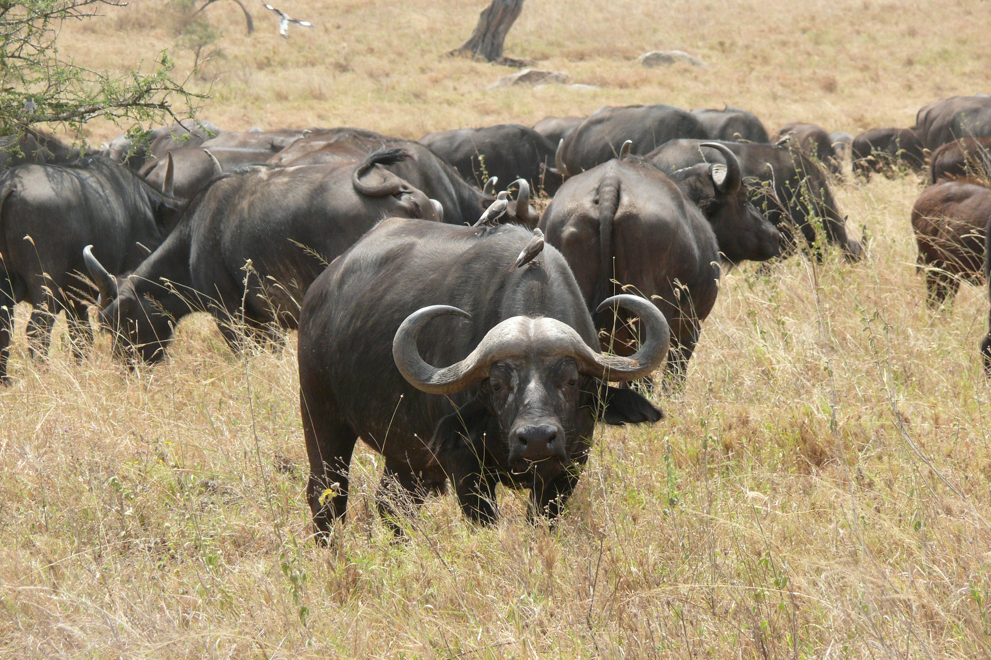](https://www.google.com/url?sa=i&rct=j&q=&esrc=s&source=images&cd=&cad=rja&uact=8&ved=0ahUKEwje0PSlp63MAhUFeCYKHdMgC6EQjRwIBw&url=https://en.wikipedia.org/wiki/African_buffalo&psig=AFQjCNEwnUw_KbTxthsYYgjOwxZ9s4y2tQ&ust=1461794436644637)

**“African or**

**From the Western US**

**What’s your guess?**

**Either way, what a mess”**

[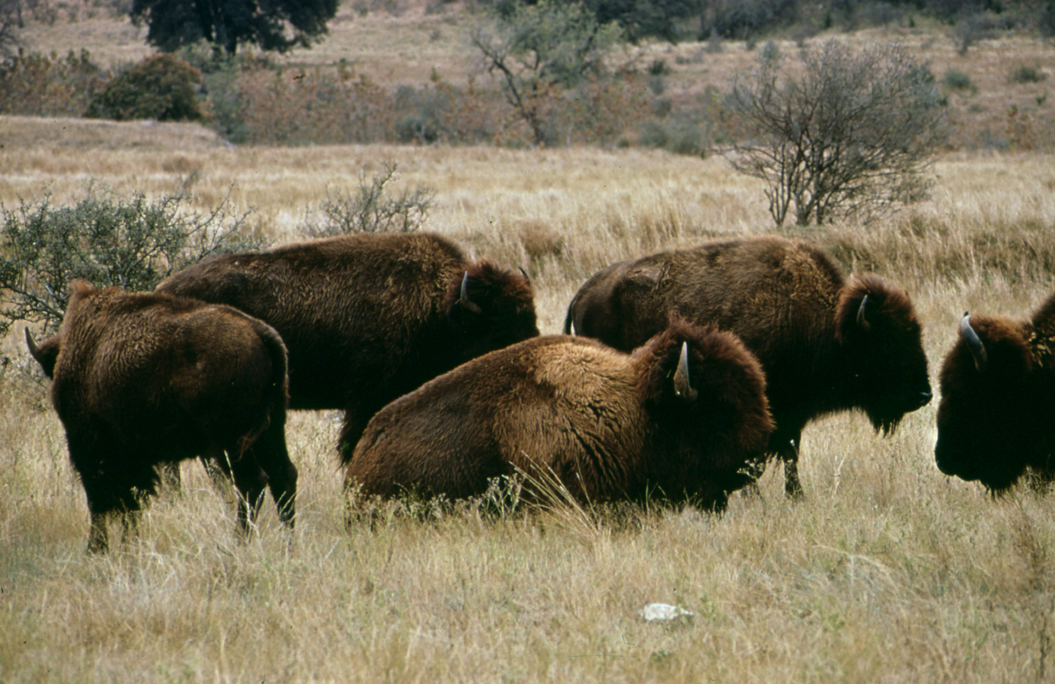](http://www.google.com/url?sa=i&rct=j&q=&esrc=s&source=images&cd=&cad=rja&uact=8&ved=0ahUKEwjs-YqBp63MAhXBKyYKHVa4C0sQjRwIBw&url=http://www.spirit-animals.com/buffalo/&psig=AFQjCNEwnUw_KbTxthsYYgjOwxZ9s4y2tQ&ust=1461794436644637)

**“I’ve been told**

**The ice cream can be too cold.”**

[](http://www.google.com/url?sa=i&rct=j&q=&esrc=s&source=images&cd=&cad=rja&uact=8&ved=0ahUKEwjnvrnvxYzMAhUGFT4KHS6ZDJkQjRwIBw&url=http://www.inquisitr.com/2722187/mary-dye-virginity/&psig=AFQjCNElwR2572M16tuYfrrzLuesFnGjDQ&ust=1460668728758324)

“Mom” Picture

**“What if Amelia got a freezer brain? She might become insane.”**

[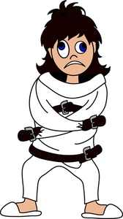](https://www.google.com/url?sa=i&rct=j&q=&esrc=s&source=images&cd=&cad=rja&uact=8&ved=0ahUKEwj088C11bHMAhWFej4KHRSeBgMQjRwIBw&url=https://forjenssake.wordpress.com/2011/07/&psig=AFQjCNFWrBWORND32cYWNk4XacaHYm5FiQ&ust=1461944374620301)

[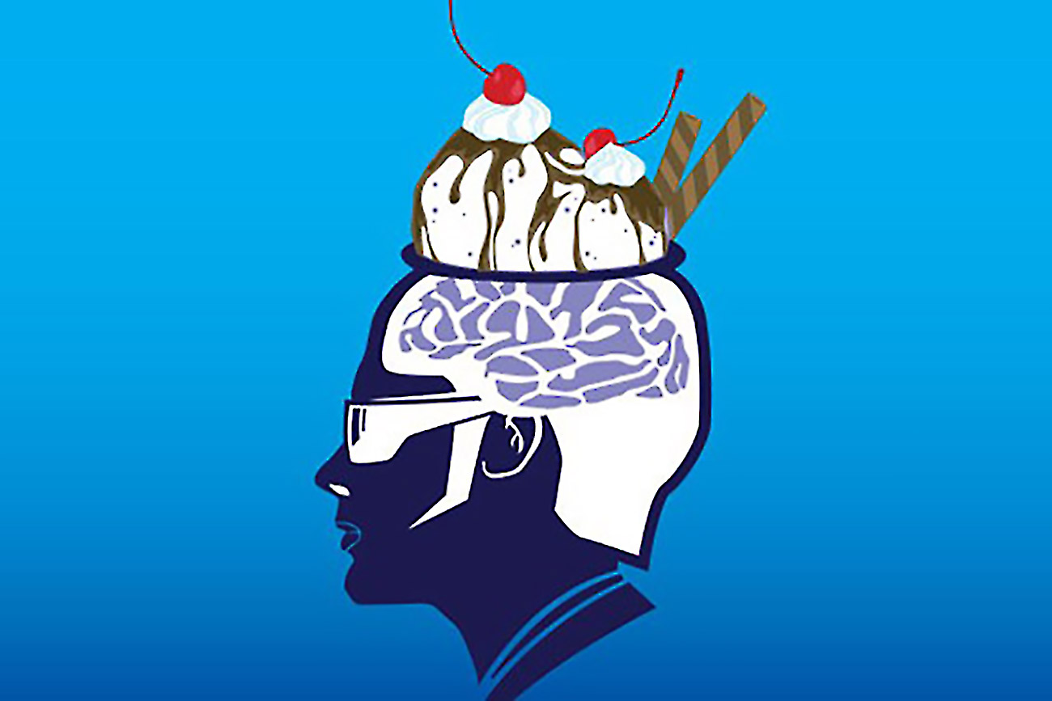](https://www.google.com/url?sa=i&rct=j&q=&esrc=s&source=images&cd=&cad=rja&uact=8&ved=0ahUKEwjy3qymqubMAhVKKiYKHWUEAccQjRwIBw&url=https%3A%2F%2Fwww.entrepreneur.com%2Farticle%2F236810&psig=AFQjCNGAhWgCSf9I6grLNcJkf7EmyiMvMg&ust=1463753881140192)

**“What if the candles I got**

**are too hot?**

**What if the invitations**

**Fail to arrive by mail?**

**What if I forget**

**how to bake a cake?”**

***And all the family told Mother….***

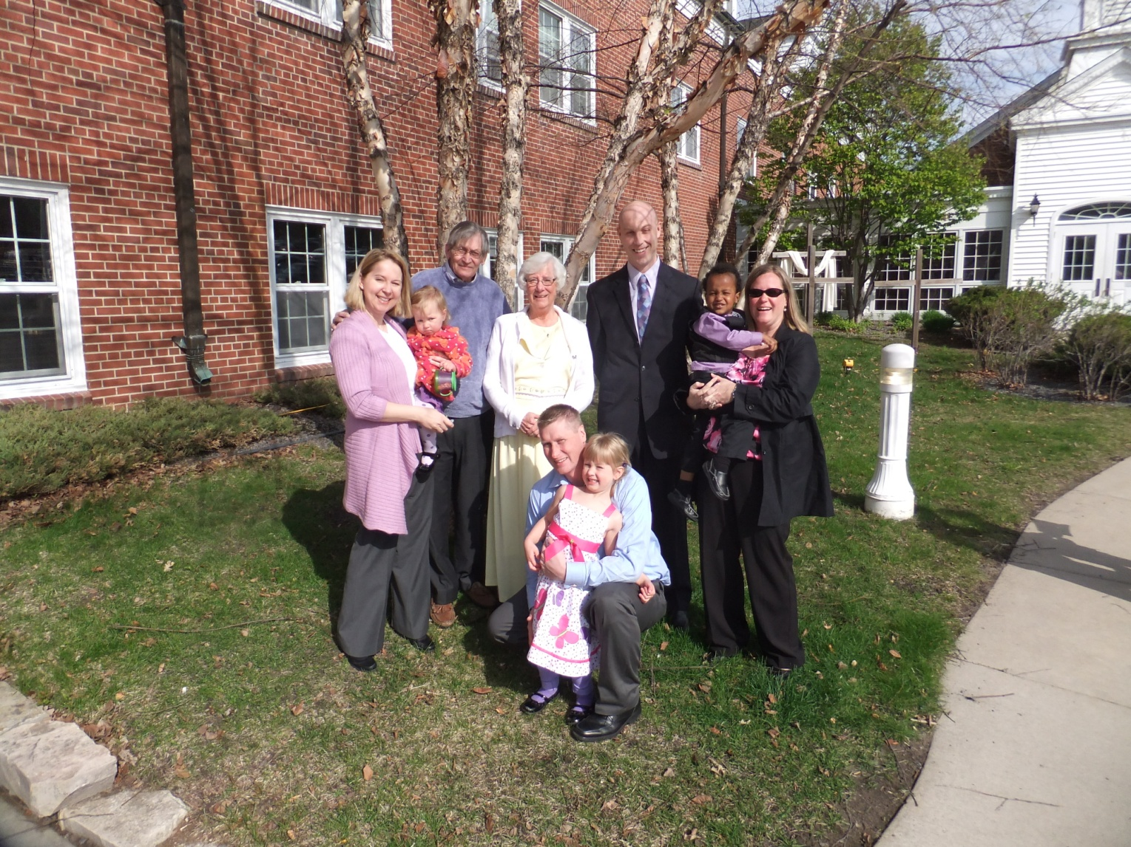

**“I didn’t know you were the sort**

**To be a worry wart.”**

Extended family or neighborhood photo

***“Don’t worry about a little hitch or glitch.”***

**“Don’t be in such a hurry**

**Looking for reasons to worry.”**

**And Mother said, “Ok. Come what may…**

**It’s Amelia’s birthday.”**

[](http://www.google.com/url?sa=i&rct=j&q=&esrc=s&source=images&cd=&cad=rja&uact=8&ved=0ahUKEwj2m7iAsObMAhWBTyYKHcfsC6AQjRwIBw&url=http%3A%2F%2F3tallstars.com%2Fbirthday-parties%2F&psig=AFQjCNGVNwhpFOe0rGopkWHZ2Lxo5D6Q-Q&ust=1463755412986208)

**Let’s Party Hardy!**

**Mother sat at the kitchen table and said, “For this party we are ready, willing, and able.**

**I insist we have missed nothing on the list.”**

[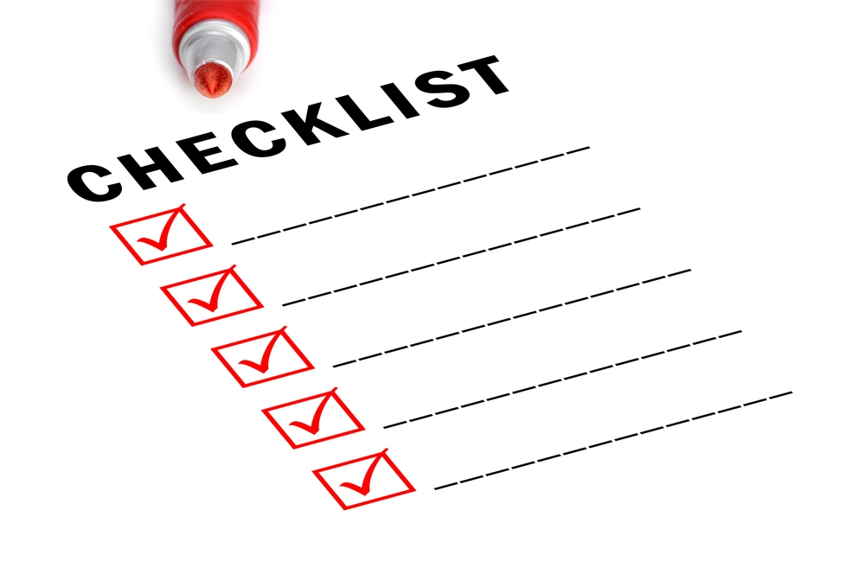](http://www.google.com/url?sa=i&rct=j&q=&esrc=s&source=images&cd=&cad=rja&uact=8&ved=0ahUKEwjF9ZS91rvMAhUnvYMKHV7YAzQQjRwIBw&url=http://annekoonsrealestate.com/home-selling-checklist/&psig=AFQjCNHLlCDDoWglCBgjCW8mGSd83Gh5qg&ust=1462288273751091)

**When the party was done**

**every kid said they had fun.**

**Everyone, even Mother had to confess**

**The party was a great success.**

**One dad said, “you are so clever,**

**best party ever.”**

[](http://www.google.com/url?sa=i&rct=j&q=&esrc=s&source=images&cd=&cad=rja&uact=8&ved=0ahUKEwj__ayO8rvMAhUKmoMKHZ2BDdsQjRwIBw&url=http://www.debifeinman.com/tag/birthday/&psig=AFQjCNGyRuBaPQCoI028DHiatibfn8YSEA&ust=1462295603273000)

**When the time came Am**

**Amelia said out loud**

**That she was so proud.**

**With a twinkle in her eye and a smile ever so sly she pointed and said, “We should have a party for you. I know just what to do.”**

[](http://www.google.com/url?sa=i&rct=j&q=&esrc=s&source=images&cd=&cad=rja&uact=8&ved=0ahUKEwjnvrnvxYzMAhUGFT4KHS6ZDJkQjRwIBw&url=http://www.inquisitr.com/2722187/mary-dye-virginity/&psig=AFQjCNElwR2572M16tuYfrrzLuesFnGjDQ&ust=1460668728758324)

Picture next party person

“But……

**What if ……..?”**

**They all laughed!**

[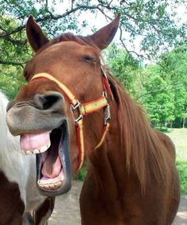](https://www.google.com/url?sa=i&rct=j&q=&esrc=s&source=images&cd=&cad=rja&uact=8&ved=0ahUKEwjEqvfA9LvMAhVGQCYKHW3_AJgQjRwIBw&url=https://www.pinterest.com/pin/445715694340861062/&psig=AFQjCNGwMwf6IXwOwXuiJiOo-UvmqmVrMQ&ust=1462296035115983)

[](http://www.google.com/url?sa=i&rct=j&q=&esrc=s&source=images&cd=&cad=rja&uact=8&ved=0ahUKEwiKsdev87vMAhWGOiYKHRtMCjAQjRwIBw&url=http://www.personal.psu.edu/afr3/blogs/SIOW/2011/09/why-laughing-makes-you-feel-so-good.html&psig=AFQjCNGwMwf6IXwOwXuiJiOo-UvmqmVrMQ&ust=1462296035115983)

[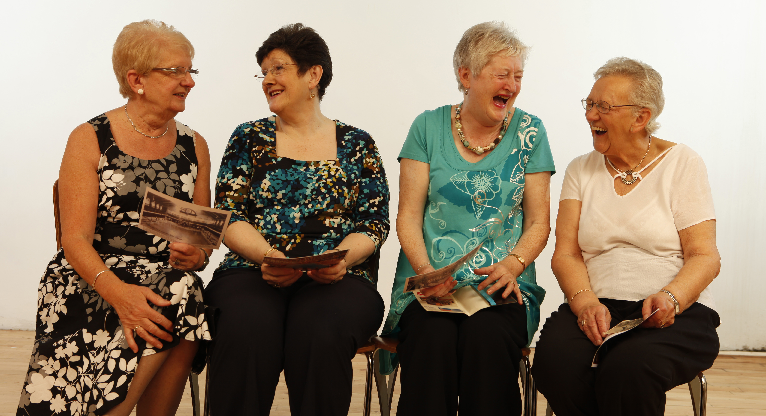](https://www.google.com/url?sa=i&rct=j&q=&esrc=s&source=images&cd=&cad=rja&uact=8&ved=0ahUKEwjls5GJnbzMAhUqkYMKHUgYAXAQjRwIBw&url=https://www.ucl.ac.uk/news/news-articles/1115/101115-change-humour-sign-dementia&psig=AFQjCNGP38hFAVc7FIYqiICV7qh97QAyfg&ust=1462307143818820)

[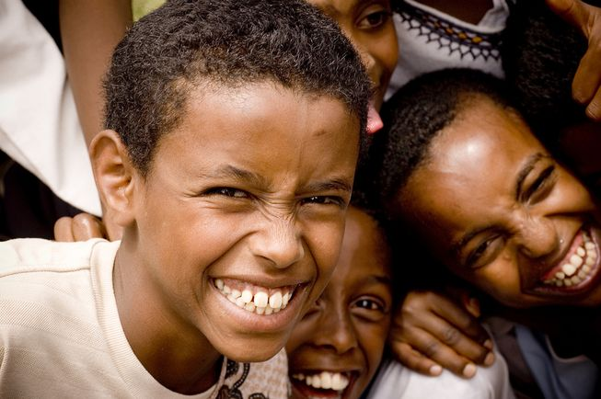](http://www.google.com/url?sa=i&rct=j&q=&esrc=s&source=images&cd=&cad=rja&uact=8&ved=0ahUKEwjxz5bR87vMAhWKQiYKHR-fCfYQjRwIBw&url=http://www.mnn.com/lifestyle/arts-culture/stories/why-laughter-contagious&psig=AFQjCNGwMwf6IXwOwXuiJiOo-UvmqmVrMQ&ust=1462296035115983)

**The Happy End**